SWECC004 — PhotoFolia analysis
Greenness measurement, UV-Vis validation, and nutrient correlation
Natuurbegraafplaats Huis ter Heide, De Moer (Zeist) — seven oaks
Nālani Balcells · Avans University of Applied Sciences · June 2026

1. Purpose and design
PhotoFolia is a smartphone application that quantifies leaf colour from a calibrated photograph and returns a set of CIE Lab and HSV colour metrics (L*, a*, b*, C*, h, H, S) together with the underlying spectral reflectance from 400 to 700 nm. The motivation for using it within SWECC004 was to test whether a fast, non-destructive smartphone measurement could substitute for the destructive lab UV-Vis chlorophyll extraction in routine oak-vitality monitoring at Huis ter Heide. This document reports three analyses on the dataset: a description of the PhotoFolia readings themselves, a leaf-by-leaf validation against the UV-Vis chlorophyll extractions (Lichtenthaler &amp; Welburn, 1983, in 80 % acetone), and a tree-level comparison against the MP-AES leaf nutrient data.
Each of the seven study oaks (FT01–FT03 Bokashi, NFT04–NFT06 Untreated, HT07 Healthy reference) was photographed by PhotoFolia at twenty-four leaf surfaces — three leaves per cardinal direction (N, E, S, W) and the adaxial proximal and adaxial distal positions of each leaf — giving 168 readings overall. The same 168 leaf surfaces were taken to the laboratory and measured by UV-Vis spectrophotometer at 645 and 663 nm, producing a paired dataset in which every PhotoFolia reading has a matched chlorophyll extraction.

2. PhotoFolia colour metrics by tree
Across the seven trees the PhotoFolia colour metrics separate the healthy reference tree from the rest more cleanly than they separate the two treated groups (Figure 1). HT07 has the highest hue angle and the lowest L* (lightness), b* (yellow direction) and chroma — that is, its leaves are the most saturated true-green of any tree. T2 (bokashi) sits second on most metrics; T1 and T5 are the lowest-greenness trees of the bokashi and untreated groups respectively. Sampling-design checks on the 168 raw readings show no systematic effect of cardinal direction on a* (Figure 2, left), and a measurable but small proximal–distal offset on a* (Figure 2, right): the distal position is consistently slightly less green than the proximal position, but the difference is much smaller than the between-tree variation, so averaging the two positions is defensible. It should be noted that measurements were confined to the adaxial (upper) surface throughout; the abaxial surface was not photographed, meaning PhotoFolia readings represent upper-surface greenness rather than a whole-leaf average.
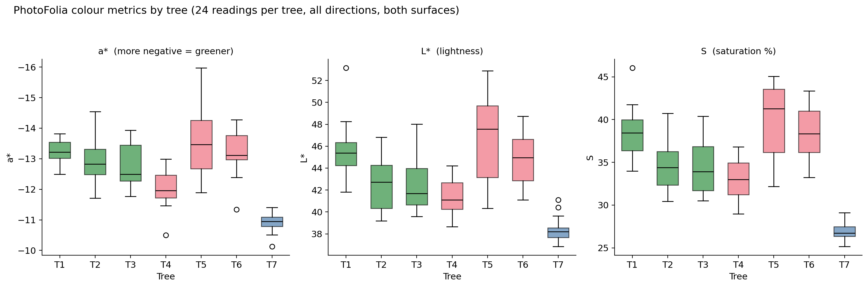
Figure 1. PhotoFolia colour metrics by tree. a* is inverted so up = greener; L* is lightness; S is saturation. Box shows median and IQR; whiskers extend to 1.5 IQR.
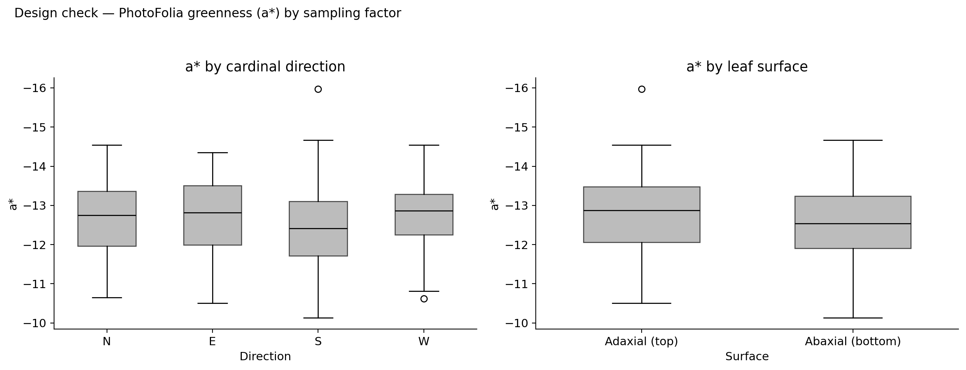
Figure 2. Sampling-design check. PhotoFolia a* (inverted so up = greener) by cardinal direction (left) and by leaf position — proximal vs distal (right). Direction has no systematic effect; position shows a small proximal–distal offset.

Group means across all PhotoFolia metrics
Aggregating to the treatment level (Figure 3), the bokashi-treated trees show slightly more pure-green readings than the untreated group on the hue angle h and the saturation S, with the healthy reference tree sitting above both treated groups on every metric. The differences between Bokashi and Untreated on the PhotoFolia metrics are smaller in absolute terms than the differences between either treated group and the healthy reference, which is consistent with the integrated picture reported in the comparison analysis: both treated groups are visibly stressed, and bokashi has not yet lifted the treated trees to the healthy reference level.
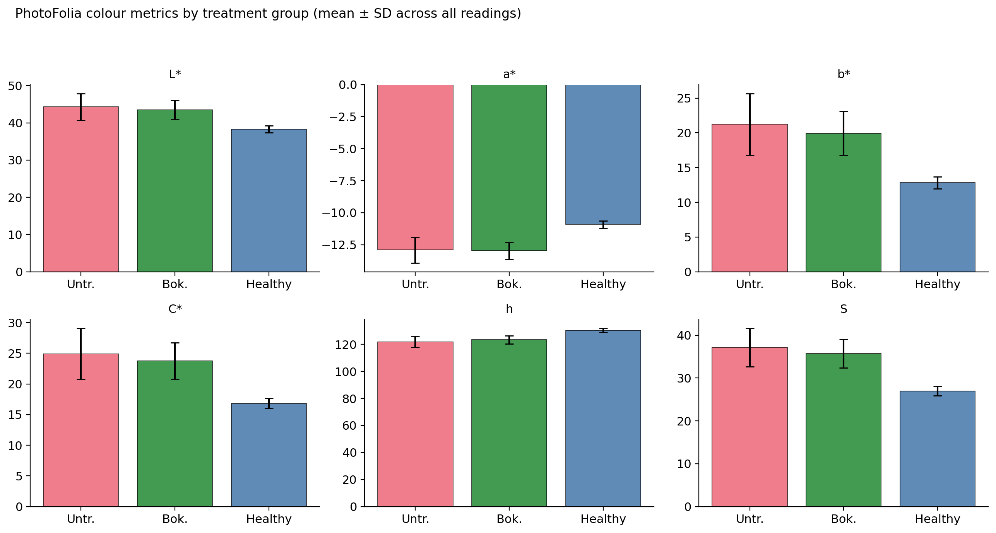
Figure 3. PhotoFolia colour metrics by treatment group. Bars are means; error bars are one SD across all readings in each group (n ≈ 72 Bokashi, 72 Untreated, 24 Healthy ref).

3. Validation against UV-Vis spectrophotometer
The leaf-by-leaf validation is the most important result in this document and is unambiguous: PhotoFolia colour metrics track the lab UV-Vis chlorophyll concentration strongly across all 168 paired observations (Figure 4). Only the three independent CIE Lab components are shown — L*, a* and b* — because chroma C* and hue angle h are mathematical functions of a* and b* (C* = √(a*² + b*²), h = atan2(b*, a*)) and saturation S is the HSV translation of the same colour, so they carry no independent information. Of the three Lab axes, the yellow ⇄ blue component b* is the strongest predictor of chlorophyll (r = −0.81, n = 168, p < 10⁻⁴⁰), with L* (r = −0.81) close behind. The interpretation is straightforward: a leaf with more chlorophyll absorbs more across the visible spectrum, appearing both darker (lower L*) and less yellow (lower b*). The red ⇄ green axis a* is the weakest predictor (r = +0.62), because oak leaves all sit in the green half of a* — they only span a narrow range on this axis, so most of the chlorophyll-driven colour variation is carried by lightness and the yellow direction rather than by the green-red direction.
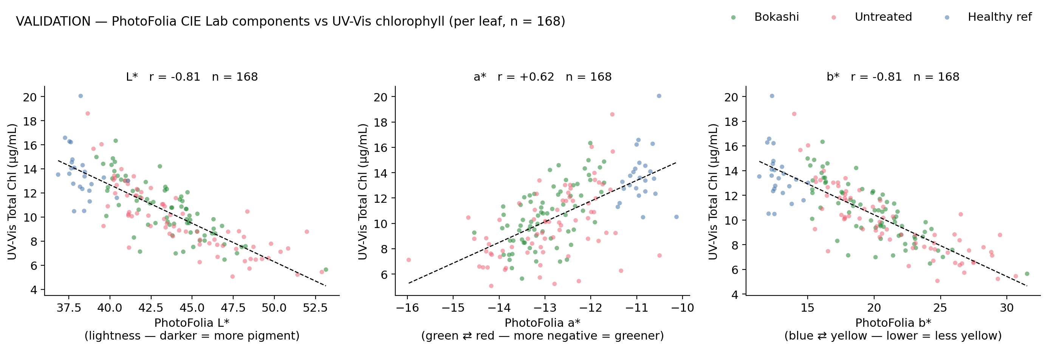
Figure 4. Per-leaf validation. Each PhotoFolia colour metric (panel) is plotted against UV-Vis total chlorophyll for the same leaf surface; dashed line is the OLS fit. Pearson r is shown in each panel.
Aggregating to the per-tree level the relationships become even tighter (Figure 5), reflecting the averaging of within-tree noise: b* vs total chlorophyll reaches r = −0.95 (p = 0.001) and L* reaches r = −0.95 (p = 0.001) at n = 7. The seven tree means cluster cleanly along a single regression line, with HT07 at the high-chlorophyll, low-b* corner and T1/T5 at the low-chlorophyll, high-b* corner.
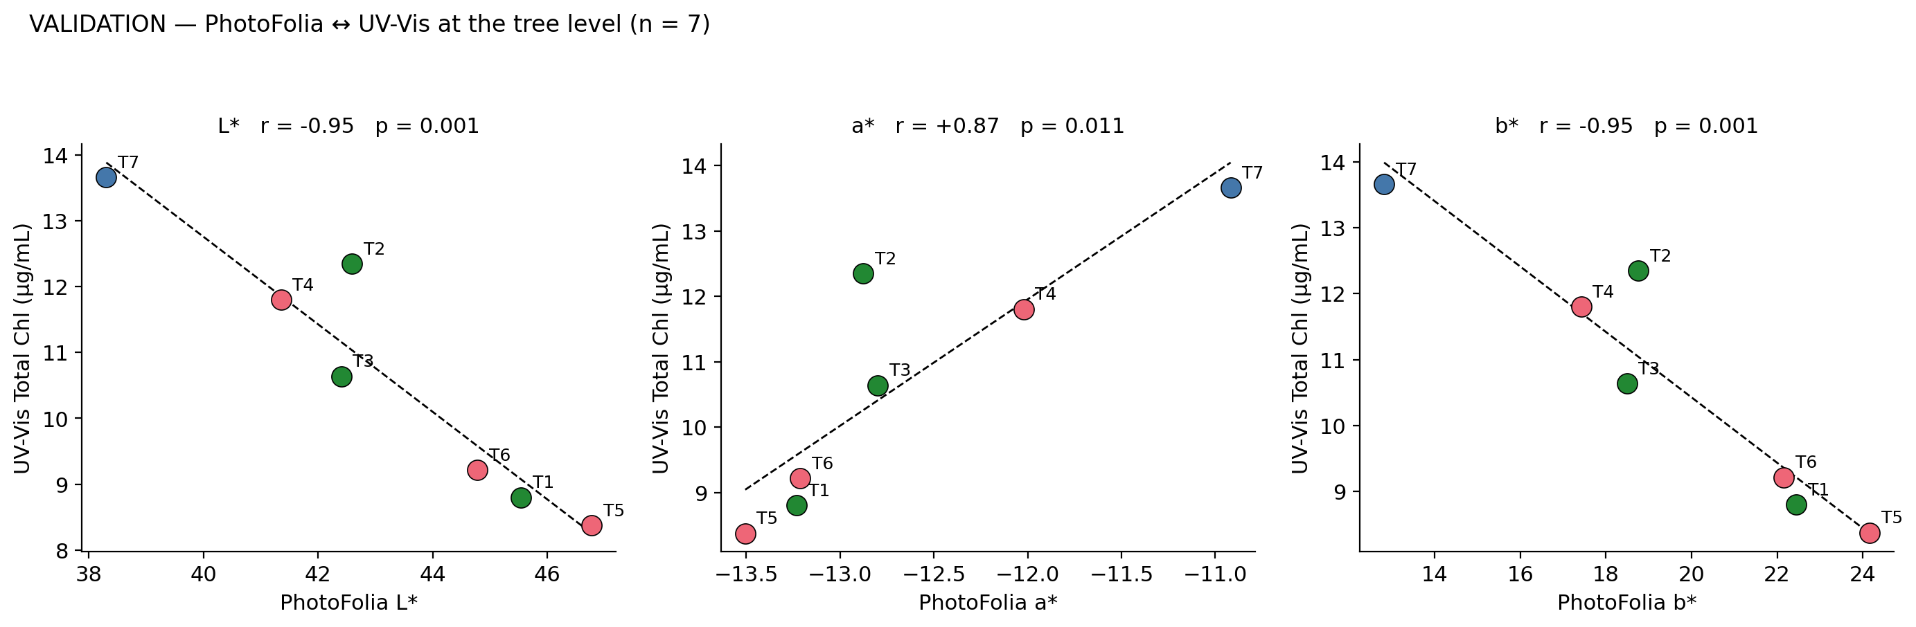
Figure 5. Per-tree validation. PhotoFolia metric means (24 readings per tree averaged) vs UV-Vis chlorophyll tree means. Pearson r is shown in each panel.

3.1 Calibration of PhotoFolia h → UV-Vis chlorophyll
Because the relationship is essentially linear in the observed range, a one-line ordinary-least-squares calibration of b* on total chlorophyll provides a practical lookup that converts a future PhotoFolia reading into an estimated chlorophyll concentration. Fitted on all 168 paired observations the model is Total_Chl (μg mL⁻¹) = −0.501 · b* + 20.44, with R² = 0.66 and root-mean-square error of 1.61 μg mL⁻¹ around the line (Figure 6). The b* axis is preferred over the equivalent hue-based calibration because it is one of the three independent CIE Lab components and therefore travels with the published colour-space convention. For the typical range of b* observed at this site (≈ 13 to 30) the calibrated PhotoFolia reading predicts chlorophyll to within roughly ±1.6 μg mL⁻¹, which is comparable to the within-tree variability of the lab method itself. This is the result that makes PhotoFolia a viable replacement for routine destructive sampling in subsequent monitoring rounds.
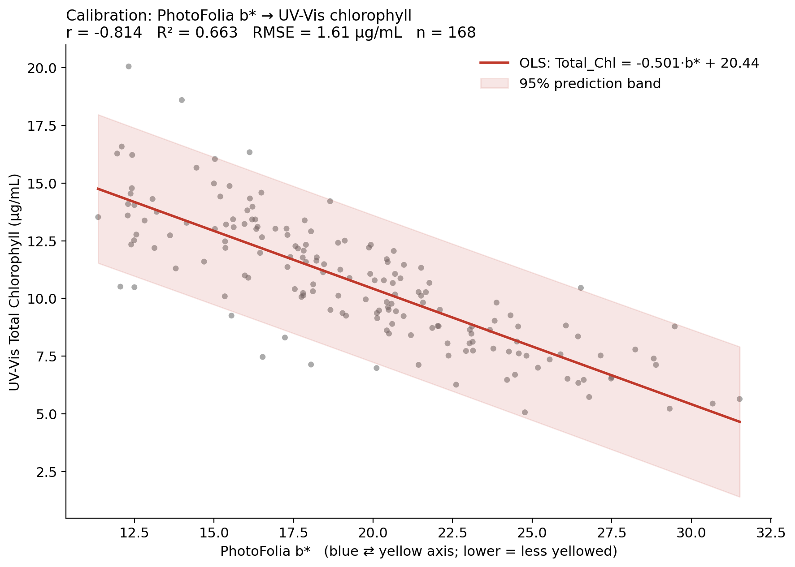
Figure 6. Calibration model. PhotoFolia hue angle h converted to UV-Vis total chlorophyll. OLS fit (red) with 95% prediction band (shaded). Fit statistics in the subtitle.

4. PhotoFolia vs leaf nutrient concentrations
With only seven trees the per-tree correlation between PhotoFolia colour and any single leaf nutrient concentration is statistically weak (Figure 7). PhotoFolia b* shows |r| ≤ 0.40 against every reliable leaf nutrient (K, Mg, Zn, Mn, Cu) at n = 7 with no p-value below 0.4 — none of these correlations would be defensible as significant even with a more powerful test. The interpretation is not that nutrients fail to drive leaf colour — the strong PhotoFolia–chlorophyll relationship in Section 3 establishes that pigment concentration does drive colour — but rather that with seven trees and the level of within-tree noise present in both substrates the cross-substrate signal at the level of a single nutrient is too small to detect.
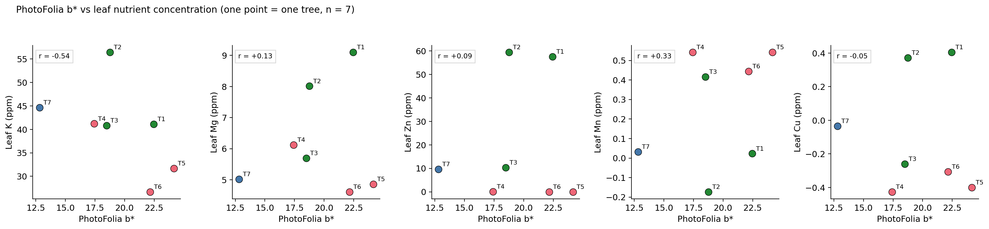
Figure 7. PhotoFolia colour vs leaf nutrient. Each point is one tree. Top row uses a*, bottom row uses h. Pearson r is shown in each panel.

5. Conclusions

5.1 PhotoFolia is validated as a chlorophyll proxy
The strongest result in this dataset is the leaf-by-leaf validation: the three independent CIE Lab components track UV-Vis chlorophyll with |r| of 0.62 (a*), 0.81 (L*) and 0.81 (b*) at the leaf level and ≈ 0.87 to 0.95 at the tree level. A one-line OLS calibration based on b* gives an R² of 0.66 and a root-mean-square error of 1.61 μg mL⁻¹ across 168 paired observations, which is acceptable for routine vitality monitoring.

5.2 Recommendation for the monitoring plan
PhotoFolia should be adopted as the primary, repeated chlorophyll-proxy measurement in subsequent monitoring rounds, with destructive UV-Vis kept as the once-per-year calibration check. The protocol that worked here (twenty-four readings per tree, three leaves per cardinal direction, adaxial proximal and distal positions averaged) is the recommended sampling design and is already documented in Chapter 3 of the SWECC004 monitoring plan. The PhotoFolia outputs that should be recorded for monitoring are b* and L*; together they capture the full chlorophyll-relevant variation in oak-leaf colour without redundancy.

5.3 Limits of the nutrient comparison
PhotoFolia colour does not, at n = 7, allow the leaf-nutrient concentration of any single element to be inferred from the photograph. This is an inherent limit of the sampling design rather than of the instrument: nutrient effects on leaf colour are partly mediated by chlorophyll (which PhotoFolia does measure well), so the cross-substrate signal at the level of a tree mean is diluted. For future projects that aim to use PhotoFolia as a nutrient screen, a larger sample of trees, sampling at multiple time points within the season, and including paired soil-nutrient measurements would all be needed.

Files in this folder
photofolia_analysis.R — full reproducible analysis script.
photofolia_matched_with_spectro.csv — 168 leaf surfaces with both PhotoFolia colour metrics and UV-Vis chlorophyll values.
photofolia_per_tree_means.csv — per-tree means used for the tree-level validation and nutrient comparison.
pf_fig1_metrics_by_tree.png … pf_fig7_vs_nutrients.png — the seven figures reproduced in this document.
SWECC004_photofolia_description.docx — this document.

